Capstone Project

## Machine Learning Engineer Nanodegree

## Anish Pillay

## August 3, 2017

## I. Definition

### Project Overview

While watching a movie, TV show or even an interview, many a times we come across a situation where we are unable to identify a celebrity or a person in the interview. A facial recognition software to identify celebrities or even a sports person during a live sporting event would be of great help. It would be amazing to see the name of the person on a flick of a button either from your TV remote or a mobile app.

In this project, I have created a facial recognition software using tensorflow to recognize celebrities in a movie clip. The application uses a Facial detection software library from dlib as well as Google’s TensorFlow software to recognize faces with incredible accuracy for limited number of input facial images.

The primary dataset used for training is a subset of Public Figures Database and for testing is a custom set of raw images. I have also created a video clip of various movie scenes or interviews of celebrities to test the model. Training Data:

Public Figures - <http://www.cs.columbia.edu/CAVE/databases/pubfig/download/>

### Problem Statement

The goal is to create a facial recognition model that could identify celebrities in images as well as video clips. The steps involved in this process are:

1. Download a celebrity dataset
2. Normalize and Preprocess the data to get only the facial content of the celebrity
3. Integrate a facial detection algorithm to efficiently identify faces in an image
4. Train a Tensorflow model to learn various facial features accurately
5. Build an image pipeline to test the model on images as well as video

This model is expected to be efficient so that it could run on a live stream with minimal lag.

### Metrics

F1 score is a good measure for multi class classification. It considers both precision and recall of the test to compute the score.

F1_score = $\frac{ 2 * P * R}{P +R}$

P= Precision R = Recall

This metric was used as it is a balanced accuracy score considering false positives as well as false negatives.

Precision lets you know how many of the predicted value is correct and recall lets you know how many of the actual labels were predicted.

## II. Analysis

### Data Exploration

The PubFig database is a large, real-world face dataset consisting of 58797 images of 200 people collected from the internet. There is a large variation in pose, lighting, scene, camera, imaging conditions and parameters. A lot of the images have 2 or more faces in them making it difficult to preprocess through code for training

Some links from the dataset text file don’t exist anymore as well as these images have different resolutions. For computing ease as well as reduced preprocessing efforts, only a subset of this database is taken into consideration. From the 200 people, 17 celebrities have been chosen to train and test the model. Each celebrity has 10 – 200 images to train on.

The dev_urls.txt file obtained for the PubFig database contains

1. Person name
2. Image Number
3. Web Link
4. Facial image coordinates in the picture
5. Md5sum link

Many of the links in the text file no longer exist or contain irrelevant graphical images which need to be discarded while preprocessing. A lot of the pictures though mentioned as a celebrity’s image, contains 2-3 people making it difficult to classify. Also, the face dimensions mentioned for many of the images are no longer valid and might give you irrelevant data. All these needs to be considered while preprocessing the data.

Due to the variation in the number of images available per celebrity, we might see a bias in predicting one celebrity as compared to the other. This issue is not a major hurdle in classification and can be easily resolved by training on more images of that celebrity.

One more important characteristic about this dataset is that the faces in the images are not aligned. Celebrity faces cold be tilted, looking down, half faces etc.

Some abnormalities or characteristics:

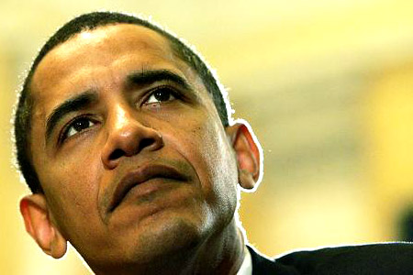 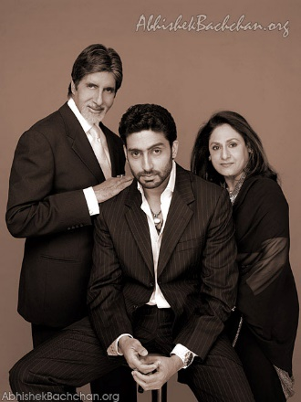

**3 Faces**

**Tilted Face**

**Wrong face in Alex Rodrigues Folder**

 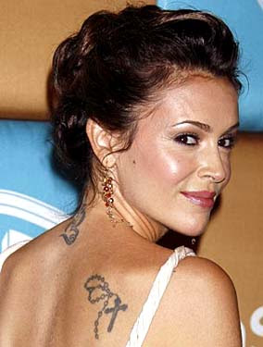 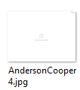

**Weird Faces**

**Side Profile**

**Image not available**

### Exploratory Visualization

The plot below shows the number of images available per class of celebrity

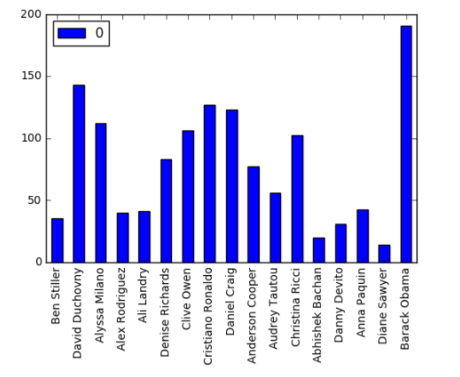

Facial features like eyes, nose, shape of the face, distance between the eyes are some of the features that the model will look at. The problem with the dataset is that the faces are not aligned. It would be beneficial to align the faces such that the eyes are relatively at the same distance from the center line for every image. The same applies for the nose and mouth. This could be considered as a normalization step that could help the algorithm to converge faster.

### Algorithms and Techniques

The classifier selected for this type of multilabel classification is a Convolutional Neural Network. CNN is a very powerful algorithm for image classification as it learns various features from the dataset automatically as well as requires less pre-processing for the images. The algorithm provides a probability for each class while classifying images and thus a threshold can be used to make definitive decisions. The threshold helps in reducing the false positives.

To start with, the following two architectures were tested:

1. Base CNN Model
2. Alexnet Architecture

With these model, the training parameters were:

* Number of Epochs
* Batch Size of images
* Optimizer Model
* Loss model
* Number of Layers
* Classification threshold
* Layer Types
* Layer Parameters
* Data Preprocessing

### Benchmark

Using these architectures, initial training brought about some computational challenges. Both the architectures could be trained with a larger resolution image but it proves to be computationally expensive or not possible with the current resource available.

For the Base CNN model, facial images were reduced to a 150 x 150 pixel image and it also had a simple architecture. With this model, I could process a batch of 30 images at a time.

The Alexnet architecture, on the other hand, had additional convolutional layers as well as Batch Normalization layers which made it computational expensive as compared to the Base CNN model. With this model, I had to reduce the resolution of images to 75 x 75 pixels which drastically affected the facial features that were visible. Even with the reduced resolution, I could send a single image to train at a time.

After comparing the two algorithms, I decided to stick to the Base CNN model as my starting point.

With the Base CNN model, I achieved 84% accuracy while training and 40% accuracy on validation set on a 50 Epoch and 2000 sample per epoch session. I considered this as my benchmark and wanted to reduce the number of samples per epoch along with increasing accuracy with a modified version of the model.

## III. Methodology

### Data Preprocessing

The downloading of images as well as cropping images is done in ‘Preprocessing_Images.ipynb’. Instead of using the facial dimension from the dev_url.txt, I used HaarCascade to detect faces in an image and crop them using the dimensions provided by OpenCV CascadeClassifier. These images were written to its respective class folder within ‘dataset_cropped’ folder.

Other preprocessing steps include:

1. Algining Faces in the image
2. Converting to grayscale
3. Flipping the images to not let the model overfit
4. Adding Gaussian Blur to generalize class images appropriately
5. Random Brightness to images

I quickly realized that aligning images while reading them and sending them as an input to the model would increase the training time. So I created a function to align faces and save them in a separate folder ‘dataset_aligned’. This helped tremendously decrease my computing time and cost.

Multiple faces in an image caused multiple faces to be saved in the folder. These images had to be manually deleted to eliminate the model from learning wrong images.

Before Preprocessing

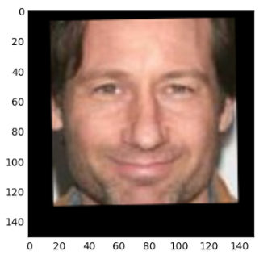

After Preprocessing:

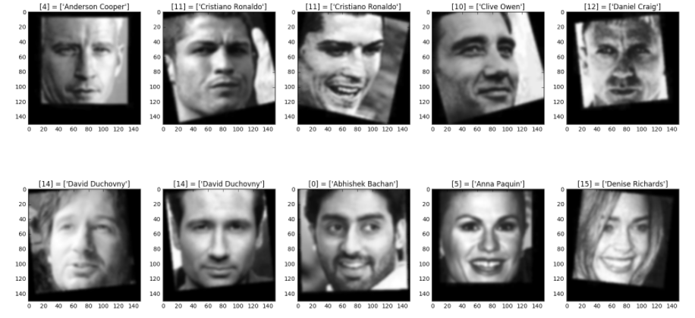

Other Feature exploration methods were also tested to see if the model learns better with them, but it did not result in any significant improvement

Color Exploration:

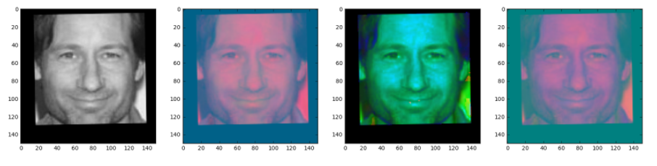

Canny Edge, Hog Features, Emphasizing Grayscale as well as a combined result

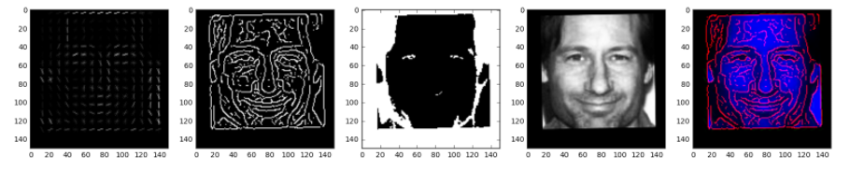

### Implementation

To implement the technique of facial recognition, it was important to get the preprocessing of images correctly and to generalize images across the same class of data. This was taken care of with the preprocessing step.

Further, a baseline model needed to be developed so as to compare future results with. As the models selected were Tensorflow models which require computationally higher RAM as well as speed, I created a data generator function that could feed the model with required number of samples per batch. The samples provided had to be preprocessed as well.

The baseline CNN model consisted of 3 convolutional layers with ReLu Activation and MaxPooling followed by 2 Dense layers and a sigmoid activation to classify the images. The Loss model chosen was ‘sparse_categorical_crossentropy’ keeping in mind that it’s a multiclass classification problem. Adam Optimizer was used for this purpose as it can be directly used without changing its parameters for initial assessment.

A heavy dropout layer was used to randomly remove 50% of features before the last layer and thus avoid overfitting

The layout of the algorithm is as shown below with an input image size of 150 x 150 pixels

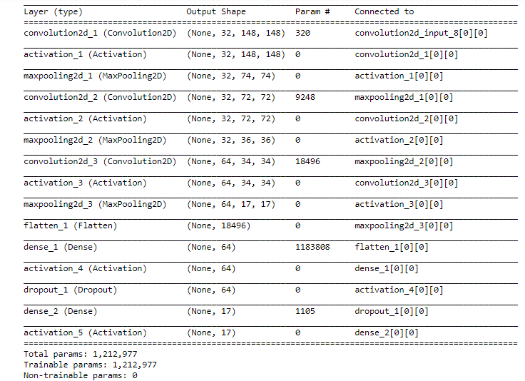

Initially the model was tuned based on the parameters mentioned above for 4 epochs to record if the accuracy had an upward trend. As soon as I saw accuracy increasing, I increased the number of epochs and trained my model. The model weights were saved in a h5 file. After each epoch, the model also gives out a validation accuracy.

Some observations made while tuning was, normalizing of image pixels helped train the model faster, Gaussian blur worked as a good generalization technique, flipping images as well as randomly increasing/decreasing brightness helped in reducing overfitting.

I created an image pipeline to serve the video demonstration part of the project. This pipeline took image as an input, detected faces as well as aligned and cropped them to feed it to the model predictor.

### Refinement

Upon setting the baseline and achieving an accuracy of 84 % on the training set. I tested the Alexnet architecture which proved to be computationally very expensive as explained before. I modified the CNN model to get better accuracy with the limited dataset that I had.

Inspired from Alexnet, I added Batch Normalization layers to my CNN model as well as an additional Convolutional layer. I also added an additional Dense Layer with increased number of features in each Dense layer. Additional Dropout layers heavily throw out features in the final layers thus reducing Overfitting.

I made an additional change in the image pipeline so as to atleast detect faces in the video even though the faces have not been trained using the model. I drew a bounding box around each face and a label if the face was identified with a confidence score of greater than 0.3.

The architecture for the modified CNN model is as below:

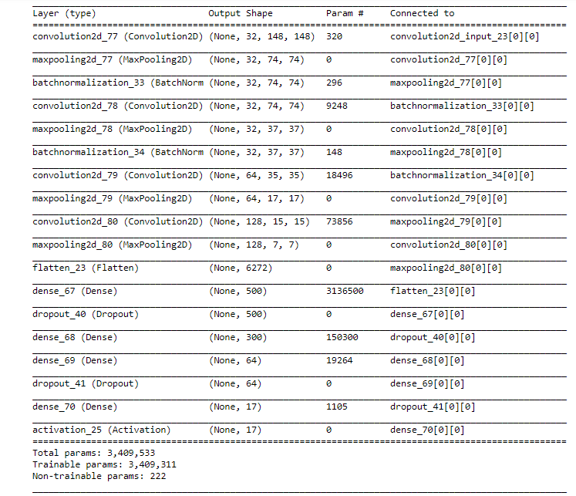

With the modified algorithm, I achieved a 96% accuracy on training data and near 90% on validation data.

A plot of the losses is shown below:

## IV. Results

### Model Evaluation and Validation

The modified CNN model was chosen as a facial recognition algorithm as it surpassed the base model in accuracy.

To verify the robustness of the model, an additional test was performed with the two models to check the improvement gain. From my research, I came across a Google Chrome extension to batch download images from google search (Fatkun Batch Download). With this software, I downloaded a bunch of images for 4 classes of celebrities. I used the image pipeline to process these images as well as predict.

While using the modified CNN model for face recognition in a video clip, I set the confidence threshold to be 0.3 so as to eliminate a lot of the false positives.

I compiled a video of 4-5 celebrities from the internet and tested my model on that video with satisfactory results.

### Justification

I used F1 score as my metric while comparing the two algorithms over this test data.

The F1 score achieved by modified CNN model was 84 % and by the base CNN model was 82%.

In the video, the algorithm recognizes most of the celebrities successfully and put out their name right beneath their faces. It is also capable of multiple face recognition. The code has been optimized so that it doesn’t take time to process each image in the video and thus can be used over a live feed.

There are some cases where the model finds it difficult to identify but it can easily be overcome with some more data possibly with more side faces.

## V. Conclusion

### Free-Form Visualization

The algorithm works form any resolution of image and performs reliably and consistenly across images or videos. There is an image pipeline as well as a video pipeline which can be used depending on the purpose.

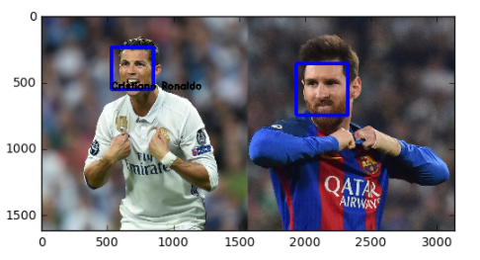

From this image above, the model works efficiently over this 3000 x 1600 pixel image with 2 celebrities with different face sizes. It labels the celebrity who was trained using the algorithm and at least detects the other celebrity face even though it does not label it.

Some grabs from the movie clip:

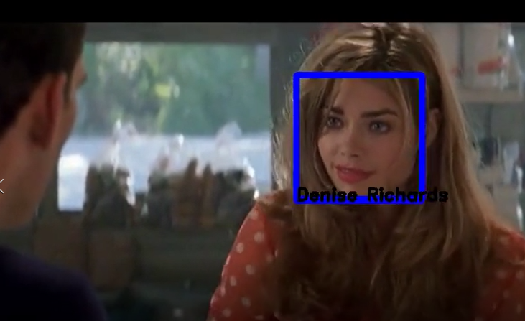

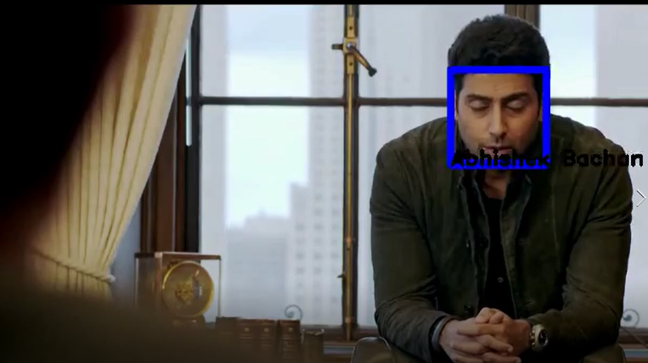 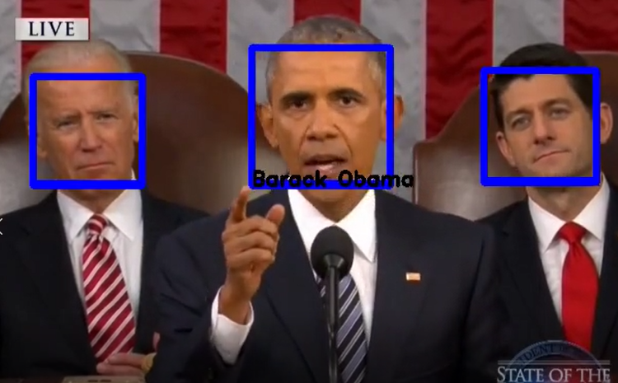

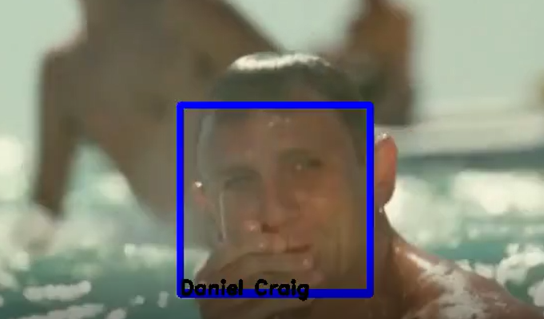 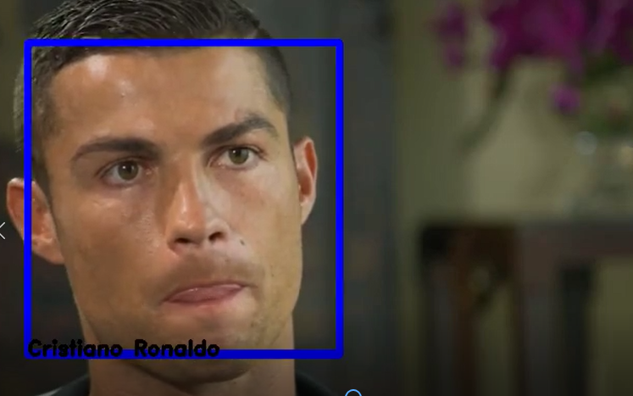

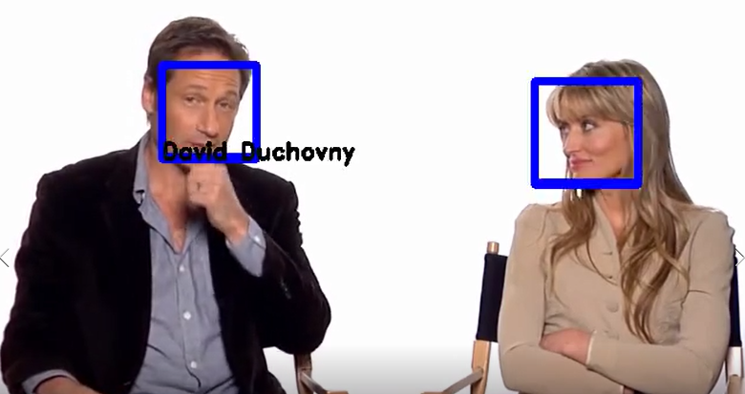

### Failure cases where the model has some difficulty

1. Side Face Profile
2. Some obstruction in front of the face
3. Very Blurry images which makes it difficult for the model to classify

### Reflection

The steps taken to complete this project can be summarized in the following steps:

1. Public dataset of celebrity images was found
2. Data was downloaded, cropped, aligned and preprocessed
3. Baseline CNN model was created as a baseline
4. The model was modified to give better accuracy with less data
5. Neural test data was collected from the internet to test both model and justify the improvement
6. Image and Video Pipeline was created to test the algorithm over a video stream

The most challenging as well as interesting steps were the 3rd and 4th step. This included getting familiar with TensorFlow, Keras, building CNN models as well as modifying them and tuning them. Video Pipeline was also a challenging task to detect multiple faces and recognize high confidence faces.

### Improvement

Some of the issues with the model can be resolved with training on more data as well as train on data with side faces or limited number of features like just the eyes and nose or nose or mouth.

Besides this, the model can also be used in mobile applications to identify celebrities by pointing your camera towards the TV.

Another major improvement could be brought about by using Alexnet which is a very powerful algorithm for image classification.

**Before submitting, ask yourself. . .**

* Does the project report you’ve written follow a well-organized structure similar to that of the project template?
* Is each section (particularly **Analysis** and **Methodology**) written in a clear, concise and specific fashion? Are there any ambiguous terms or phrases that need clarification?
* Would the intended audience of your project be able to understand your analysis, methods, and results?
* Have you properly proof-read your project report to assure there are minimal grammatical and spelling mistakes?
* Are all the resources used for this project correctly cited and referenced?
* Is the code that implements your solution easily readable and properly commented?
* Does the code execute without error and produce results similar to those reported?